
Design of AMBA-AHB Master Lite
AHB-Lite Master Design and Verification Report
Report by: Youssef Bassem Lamey
Submitted to: Eng. Fatma Ali
ADI Summer Internship 2026
Digital Design and Verification Team

Contents
1. Introduction 3
2. Master Design Features 3
2.1 Pipelined Address and Data Phases 3
2.2 Waited Transfer Cycles 3
2.3 Transfer Type Encoding 3
2.4 Transfer Size Support 4
2.5 Burst Operation Support 4
2.6 ERROR Response Handling 4
3. Architecture and Address Calculation 5
3.1 Next-Address Calculation Datapath 5
4. Finite State Machine 6
5. Test Cases and Waveforms 7
5.1 Test a — WRAP4 write, word, base 0x38 8
5.2 Test b — INCR8 write, halfword, base 0x34 8
5.3 Test c — WRAP8 read, word, base 0x38 9
5.4 Test d — INCR8 read, halfword, base 0x34 9
5.5 Test e — INCR write (count = 2) immediately followed by INCR read (count = 3), no gap 10
5.6 Test f — INCR4 write, word, base 0x38, 1 wait state 11
5.7 Test g — WRAP4 write, word, base 0x34, 2 wait states 11
5.8 Test i — INCR4 read, word, base 0x38, 1 wait state 11
5.9 Test j — WRAP4 read, word, base 0x34, 2 wait states 12
6. Conclusion 12

1. Introduction
This report documents the design of an AMBA AHB-Lite compliant bus master, developed as part of the Digital Design and Verification internship track at Analog Devices Egypt (ADI). AHB-Lite is a single-master, high-bandwidth, pipelined bus protocol defined by ARM in the AMBA 3 specification (ARM IHI 0033A), intended for high-performance synthesizable on-chip designs.
The master module generates the address, control, and write-data signals required to initiate single transfers and burst transfers of varying length, direction, and beat size, and correctly responds to slave wait states and ERROR responses. The report covers the supported feature set, the internal architecture (including the next-address calculation datapath), the governing finite state machine, and the functional test cases used to verify the design, together with their captured simulation waveforms.

2. Master Design Features
The master supports the full set of transfer types, sizes, and burst operations defined by the AHB-Lite protocol, in addition to pipelined address/data phases, wait-state handling, and ERROR-response recovery.

2.1 Pipelined Address and Data Phases
Every AHB-Lite transfer is split into an address phase and a data phase. The master overlaps these phases across consecutive transfers: while the data phase of the current transfer is completing, the address phase of the next transfer is already being driven onto the bus. This pipelining is fundamental to the high-throughput, non-tristate nature of the bus and lets the slave use the address/control information for one full clock cycle while the previous data phase is still resolving.

2.2 Waited Transfer Cycles
A slave that needs additional time to sample or supply data drives HREADY LOW, which inserts one or more wait states into the data phase and simultaneously extends the address phase of the following transfer. While HREADY is LOW, the master design keeps HTRANS and the address/control signals constant (with the defined exceptions for IDLE-to-NONSEQ and BUSY-to-SEQ transitions, and address changes following an ERROR response), and only advances to the next beat once HREADY returns HIGH.

2.3 Transfer Type Encoding
The master drives HTRANS[1:0] to indicate the type of the current transfer, as summarized below.
HTRANS[1:0] | Type | Description
00 | IDLE | No data transfer required; used between bursts or to pad the bus.
01 | BUSY | Master continues a burst but the next beat is not yet ready; address/control reflect the next beat.
10 | NONSEQ | First transfer of a burst, or a single transfer; address is unrelated to the previous transfer.
11 | SEQ | Remaining beats of a burst; address is related to the previous transfer by the transfer size (with wrap-around for wrapping bursts).

2.4 Transfer Size Support
HSIZE[2:0] is driven by the master to indicate the width of each beat. The design supports the following sizes:
HSIZE[2:0] | Size (bits) | Description
000 | 8 | Byte
001 | 16 | Halfword
010 | 32 | Word
011 | 64 | Doubleword
100 | 128 | Four-word line
101 | 256 | Eight-word line

2.5 Burst Operation Support
HBURST[2:0] selects the burst type. The master's next-address datapath supports all eight burst encodings defined by the protocol:
HBURST[2:0] | Type | Description
000 | SINGLE | Single transfer.
001 | INCR | Incrementing burst of undefined length.
010 | WRAP4 | 4-beat wrapping burst.
011 | INCR4 | 4-beat incrementing burst.
100 | WRAP8 | 8-beat wrapping burst.
101 | INCR8 | 8-beat incrementing burst.
110 | WRAP16 | 16-beat wrapping burst.
111 | INCR16 | 16-beat incrementing burst.
For wrapping bursts, the address boundary is the product of the number of beats and the transfer size; the address sequence wraps back to the lower boundary once it reaches the top of that aligned block, rather than continuing to increment.

2.6 ERROR Response Handling
If the selected slave returns HRESP = ERROR, the response is signaled over two cycles: HREADY LOW in the first cycle (OKAY held) and HREADY HIGH with HRESP held at ERROR in the second cycle. Because the bus is pipelined, the address of the following transfer has already been broadcast by the time the ERROR is recognized. The master design reacts to this by driving HTRANS to IDLE for the next transfer while HREADY is still LOW, cancelling the transaction that would otherwise have started, before resuming normal operation once the slave completes the ERROR response.

3. Architecture and Address Calculation
The master is partitioned into three cooperating blocks: a next-address calculation datapath, a control finite state machine, and address/data buffering logic that interfaces to the downstream slave/memory model. Figure 1 shows the top-level block diagram.
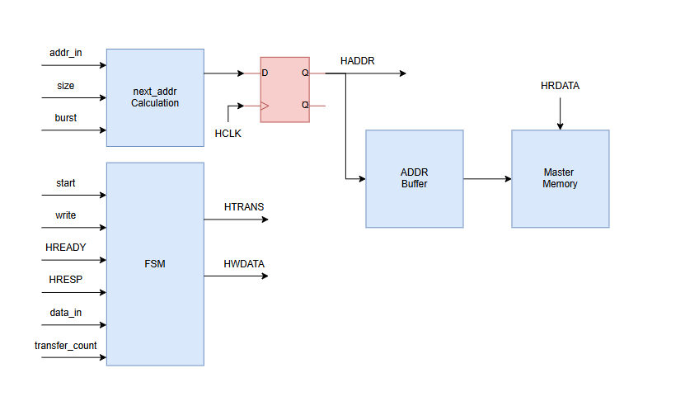
Figure 1 — Top-level block diagram of the AHB-Lite master.
The next_addr Calculation block combines addr_in, size, and burst to produce the address for the current beat, which is registered on HCLK into the HADDR output flip-flop. The FSM block drives the control outputs HTRANS and HWDATA (via write-data selection) from start, write, HREADY, HRESP, data_in, and transfer_count, and coordinates with the ADDR Buffer that holds the address for the active transfer while the Master Memory model supplies/accepts HRDATA and HWDATA during the data phase.

3.1 Next-Address Calculation Datapath
Figure 2 details the address calculation logic.
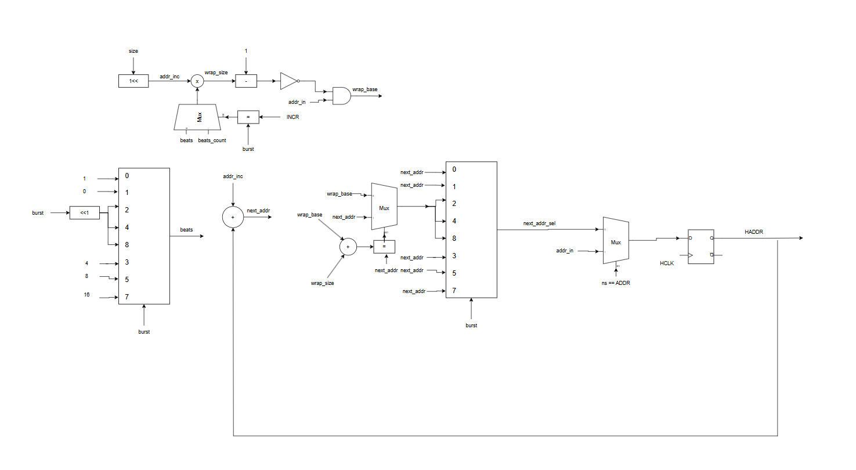
Figure 2 — Next-address calculation block diagram.
- addr_inc = 1 << size — the byte increment for one beat, derived from HSIZE.
- beats — the number of beats in the burst, selected by a burst-encoded mux (1, 2, 4, or 8 depending on whether the burst is SINGLE/undefined, WRAP4/INCR4, WRAP8/INCR8, or WRAP16/INCR16), further gated by an INCR-vs-fixed-length comparison against beats_count.
- wrap_size = (addr_inc × beats) − 1, and wrap_base = addr_in AND (NOT wrap_size) when the burst is a wrapping type — this masks addr_in down to the wrap-aligned boundary.
- next_addr = addr_in + addr_inc for the first beat; for subsequent beats the wrap-boundary comparator (wrap_base + wrap_size compared against the running address) selects between a wrapped address and a plain incrementing address.
- An 8-way multiplexor, indexed by the HBURST encoding (SINGLE, INCR, WRAP4, INCR4, WRAP8, INCR8, WRAP16, INCR16), selects the correct next_addr candidate for the current burst type.
- A final mux selects between addr_in (when the FSM's next state is ADDR, i.e. a new burst is starting) and the computed next_addr (continuing an existing burst), and the result is registered on the rising edge of HCLK to drive HADDR.

4. Finite State Machine
The master's control logic is implemented as a Moore/Mealy-mixed FSM with five states: IDLE_S, ADDR, WAIT, DATA_W (write data phase) and DATA_R (read data phase), plus an ERROR state for slave error recovery. Figure 3 shows the complete state diagram.
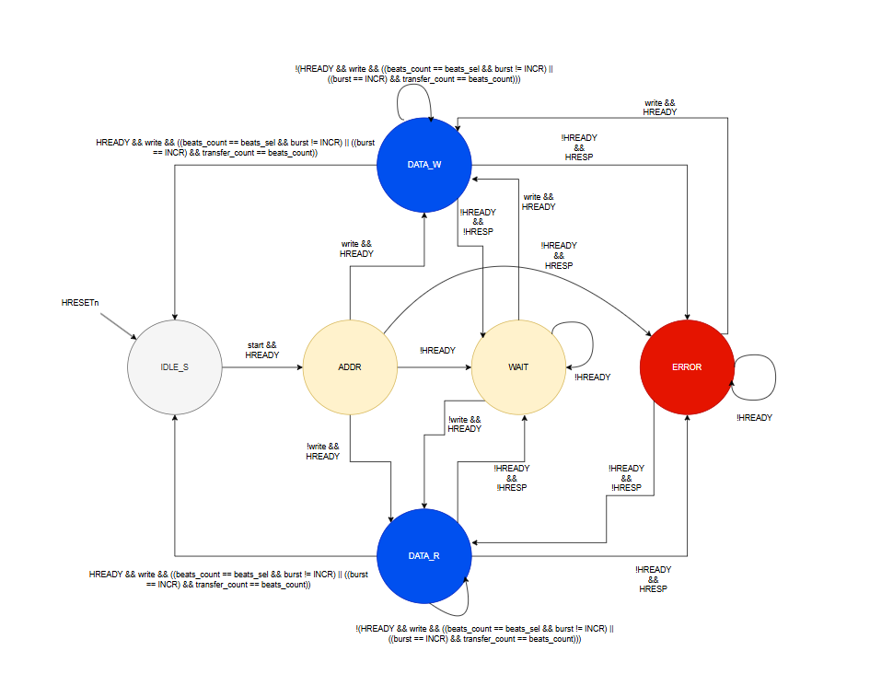
Figure 3 — AHB-Lite master control FSM.
- IDLE_S → ADDR: on start && HREADY, the master begins driving a new address/control phase.
- ADDR → DATA_W / DATA_R: the FSM branches on the write signal (write && HREADY for a write transfer, !write && HREADY for a read transfer).
- DATA_W / DATA_R self-loop: while more beats remain in the burst (beats_count not yet equal to beats_sel, or an INCR burst where transfer_count has not yet reached beats_count) and HREADY is asserted with write asserted appropriately, the FSM stays in the data-phase state and issues the next SEQ beat.
- DATA_W / DATA_R → IDLE_S: once the last beat of the burst completes (the beats-count/termination condition is met) with HREADY asserted, the FSM returns to IDLE_S to await the next transfer.
- Any data-phase state → WAIT: when !HREADY, the FSM parks in WAIT (or loops within WAIT on !HREADY) until the slave asserts HREADY, then proceeds to the appropriate data-phase state based on the write signal.
- → ERROR: from ADDR, WAIT, DATA_W, or DATA_R, the combination of !HREADY && HRESP transitions the FSM to the ERROR state, from which it returns to IDLE_S once HREADY is reasserted (with HTRANS driven to IDLE, per Section 2.6).

5. Test Cases and Waveforms
The design was verified with a directed test suite covering wrapping and incrementing bursts of different lengths and sizes, undefined-length INCR bursts, back-to-back write/read bursts with no idle gap, and wait-state insertion on both write and read transfers. Table below summarizes the test cases; the simulation waveforms follow.
Test | Burst | Direction | Size | Base Address | Wait States
a | WRAP4 | Write | Word | 0x38 | 0
b | INCR8 | Write | Halfword | 0x34 | 0
c | WRAP8 | Read | Word | 0x38 | 0
d | INCR8 | Read | Halfword | 0x34 | 0
e | INCR (write, count=2) → INCR (read, count=3) | Write → Read, no gap | — | — | 0
f | INCR4 | Write | Word | 0x38 | 1
g | WRAP4 | Write | Word | 0x34 | 2
i | INCR4 | Read | Word | 0x38 | 1
j | WRAP4 | Read | Word | 0x34 | 2

5.1 Test a — WRAP4 write, word, base 0x38
With HSIZE = Word and a 4-beat wrapping burst starting at 0x38, the 16-byte-aligned wrap boundary is 0x30–0x3F, so the address sequence is 0x38, 0x3C, 0x30, 0x34, matching the wrap-around behaviour of the address-calculation datapath. HWDATA and HADDR track together through the pipelined address/data phases.
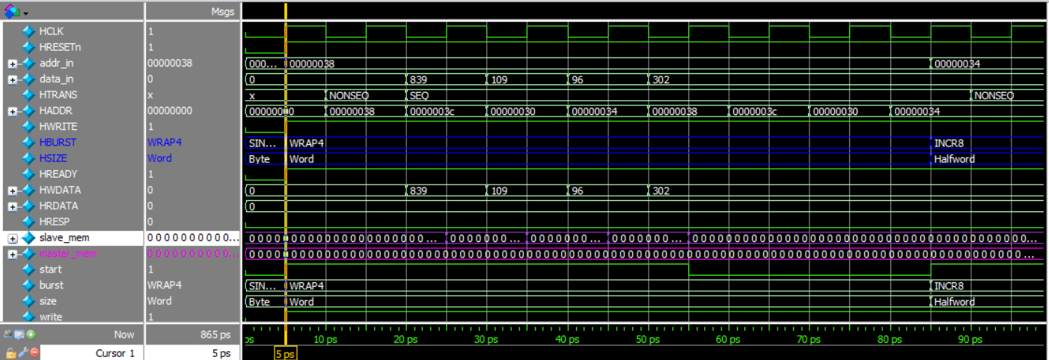
Figure 4 — Test a: WRAP4 write, word, base 0x38 (transitioning into Test b).

5.2 Test b — INCR8 write, halfword, base 0x34
Following Test a, HBURST switches to INCR8 with HSIZE = Halfword and addr_in = 0x34. The address increments by 2 bytes per beat over eight beats without wrapping (0x34, 0x36, 0x38, ... 0x46), confirming correct INCR8 operation.
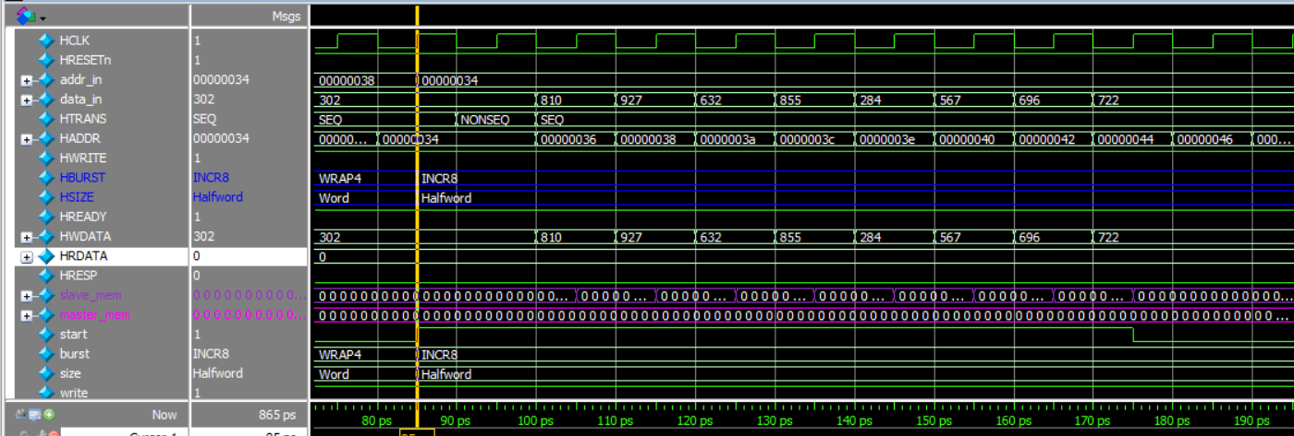
Figure 5 — Test b: INCR8 write, halfword, base 0x34.

5.3 Test c — WRAP8 read, word, base 0x38
For an 8-beat wrapping burst of words starting at 0x38, the wrap boundary is 32-byte aligned (0x20–0x3F). The captured address sequence 0x38, 0x3C, 0x20, 0x24, 0x28, 0x2C, 0x30, 0x34 confirms the wrap calculation for WRAP8, with HRDATA returned by the memory model on each beat.
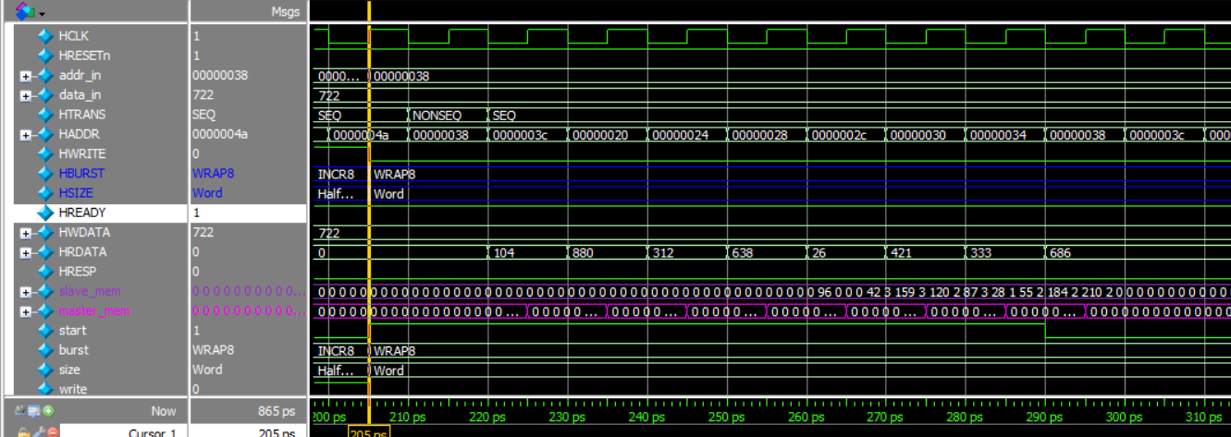
Figure 6 — Test c: WRAP8 read, word, base 0x38 (transitioning into Test d).

5.4 Test d — INCR8 read, halfword, base 0x34
Continuing from Test c, an 8-beat incrementing read burst of halfwords starting at 0x34 increments the address by 2 bytes per beat with no wrap, up to 0x44/0x46, while HRDATA supplies the corresponding read data each cycle.
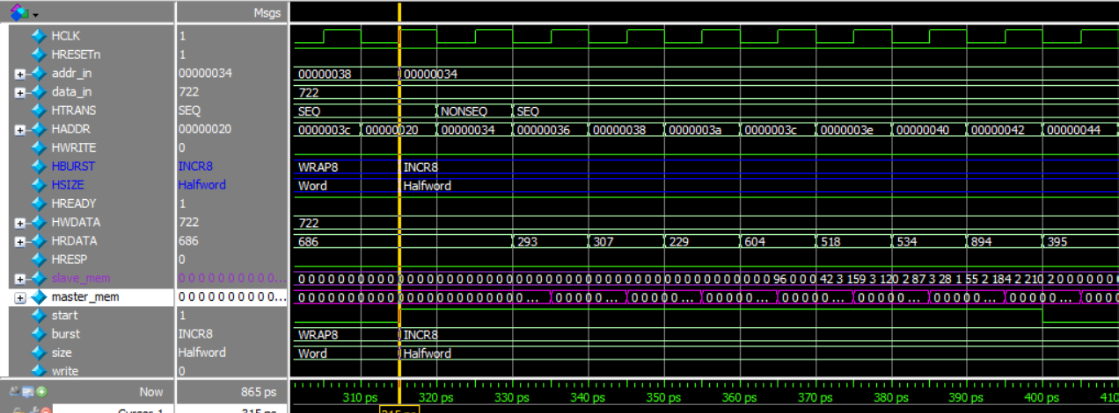
Figure 7 — Test d: INCR8 read, halfword, base 0x34.

5.5 Test e — INCR write (count = 2) immediately followed by INCR read (count = 3), no gap
This test exercises an undefined-length INCR burst that is terminated early by the master after two write beats, immediately followed — with no IDLE cycle in between — by a second undefined-length INCR burst of three read beats. The waveform shows HTRANS transitioning directly from SEQ back to NONSEQ to start the new burst, and HWRITE switching from write to read with no bus idle cycle, verifying back-to-back burst termination and re-arbitration.
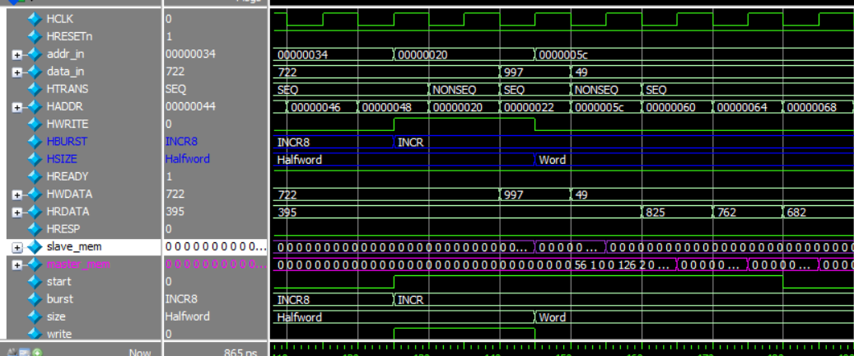
Figure 8 — Test e: INCR write (count=2) followed immediately by INCR read (count=3).
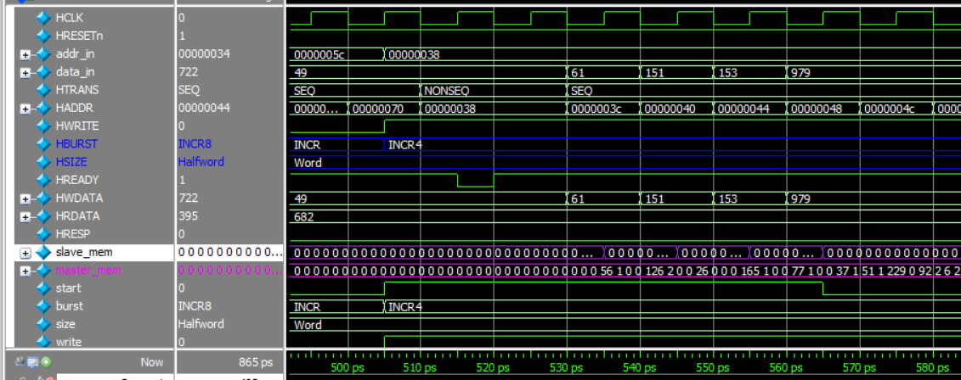
Figure 9 — Test e (continued) and transition into Test f.

5.6 Test f — INCR4 write, word, base 0x38, 1 wait state
A 4-beat incrementing write burst of words at 0x38 with a single wait state inserted by the slave. HREADY is driven LOW for one cycle, holding HTRANS and the address constant, before the transfer completes and the burst proceeds normally for the remaining beats.
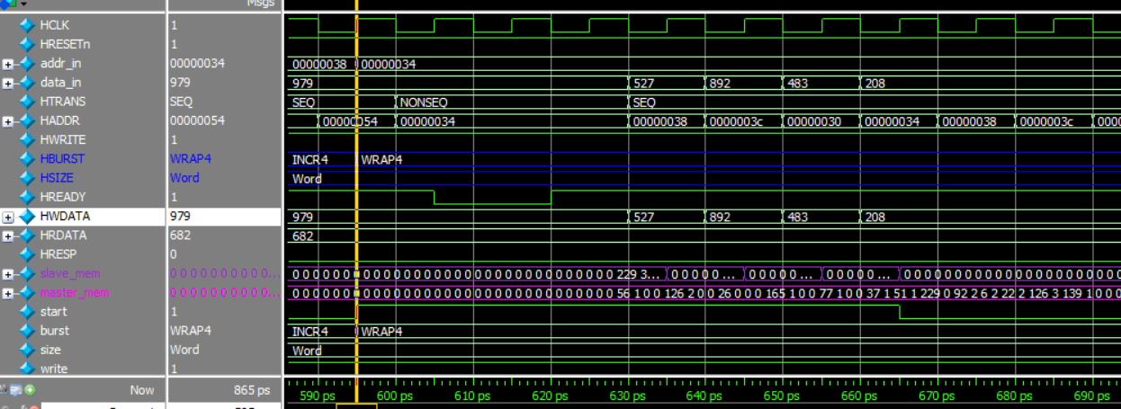
Figure 10 — Test f: INCR4 write, word, base 0x38, 1 wait state (transitioning into Test g).

5.7 Test g — WRAP4 write, word, base 0x34, 2 wait states
A 4-beat wrapping write burst of words at 0x34 (wrap boundary 0x30–0x3F) with two wait states inserted on the first beat. The FSM correctly parks in the WAIT state for two HCLK cycles before HREADY returns HIGH and the wrapping sequence (0x34, 0x38, 0x3C, 0x30) proceeds.
(Continuation of the waveform for Test f/g is captured in Figure 10 above; Figures 11–12 below capture Test i and Test j.)

5.8 Test i — INCR4 read, word, base 0x38, 1 wait state
A 4-beat incrementing read burst of words at 0x38 with one wait state inserted on the first beat. HREADY drops for a single cycle while HTRANS and HADDR are held, then the remaining three beats complete back-to-back with HRDATA returning the memory contents each cycle.
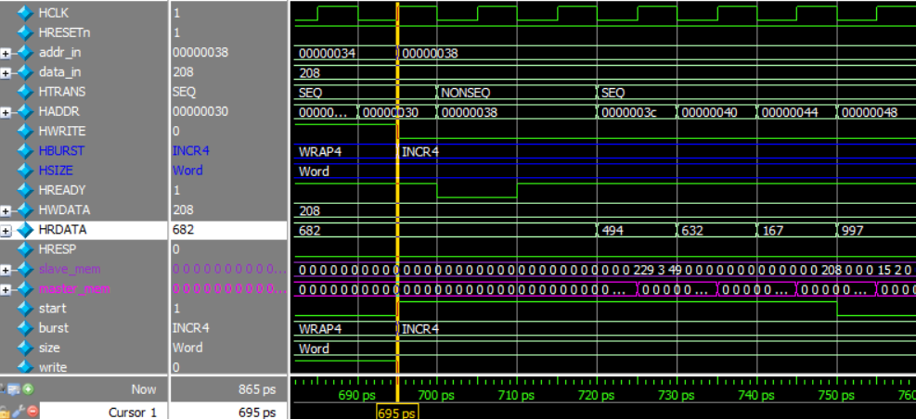
Figure 11 — Test i: INCR4 read, word, base 0x38, 1 wait state.

5.9 Test j — WRAP4 read, word, base 0x34, 2 wait states
A 4-beat wrapping read burst of words at 0x34 (wrap boundary 0x30–0x3F) with two wait states inserted before the first beat completes. The address sequence 0x34, 0x38, 0x3C, 0x30 confirms correct wrap behaviour for reads, and the two-cycle HREADY LOW period confirms correct wait-state handling on the read path.
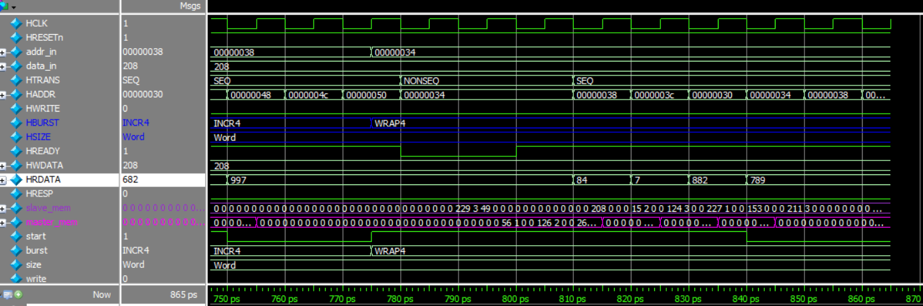
Figure 12 — Test j: WRAP4 read, word, base 0x34, 2 wait states.

6. Conclusion
The AHB-Lite master design implements pipelined address/data phases, full wait-state handling, all four HTRANS transfer types, all six supported transfer sizes, and all eight HBURST burst types, together with ERROR-response recovery. The next-address calculation datapath correctly reproduces both incrementing and address-wrapping behaviour, and the directed test suite (Tests a–j) exercises single and back-to-back bursts, both directions, multiple beat sizes, undefined-length INCR termination, and wait-state insertion on both write and read paths, with waveform captures confirming correct operation in each case.

